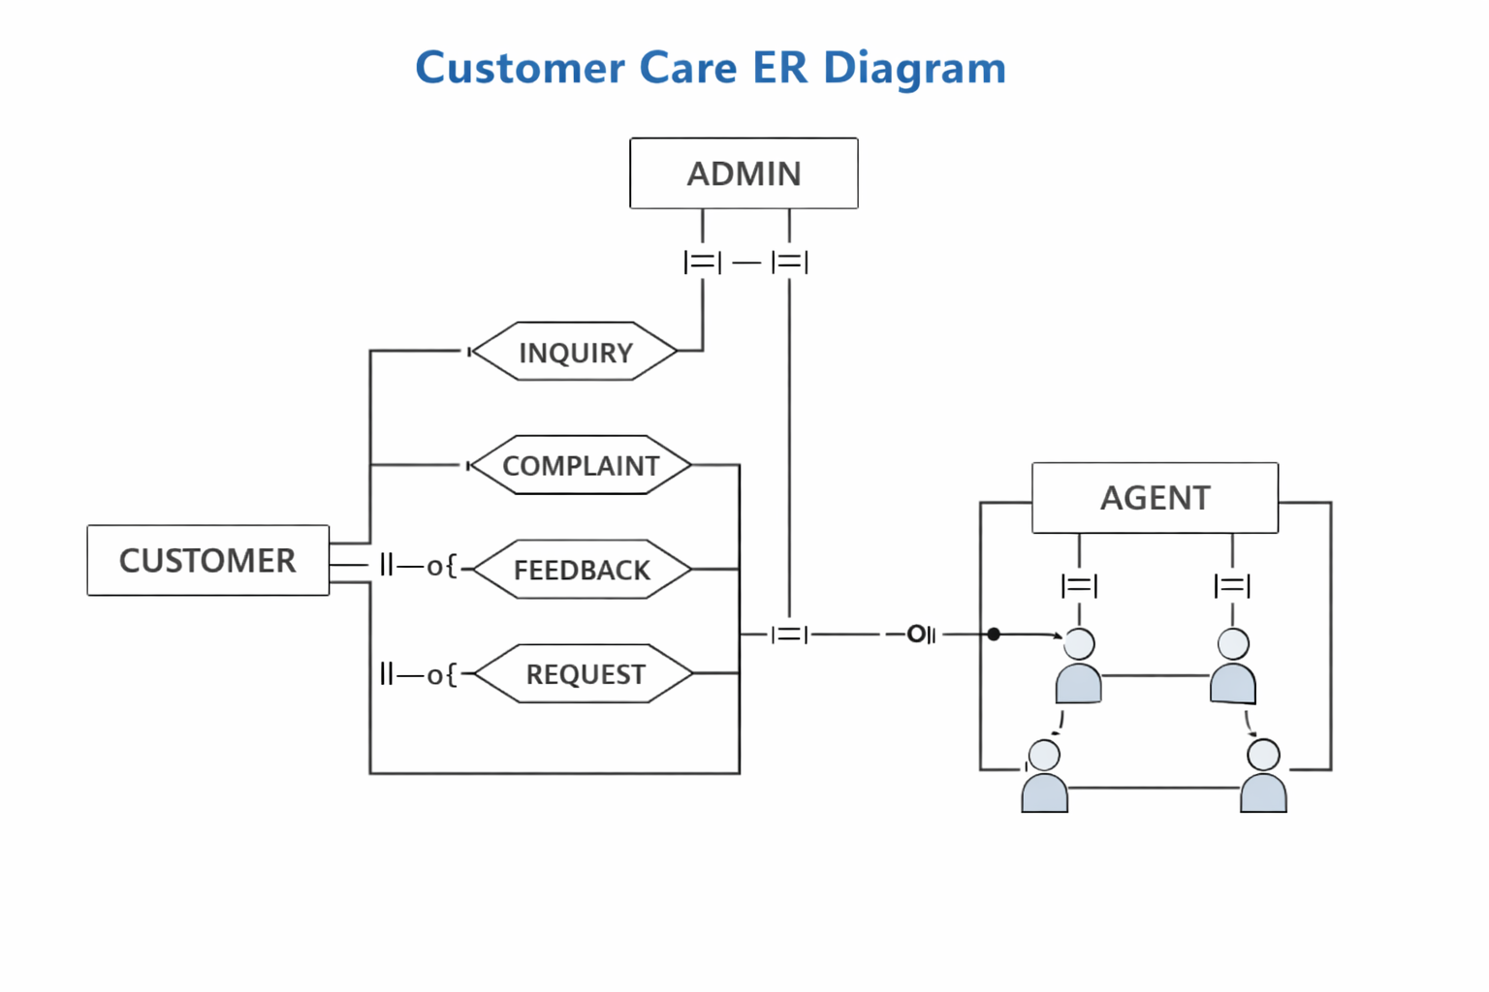
Entity | Description
Customer | Individuals or organizations who contact customer care.
Inquiry | Questions or clarifications raised by customers.
Complaint | Issues or problems reported by customers.
Feedback | Suggestions or opinions shared by customers.
Request | Service or support requests made by customers.
Agent | Customer service representatives who handle interactions.
Admin | Supervisors who manage agents and oversee system operations.

Relationships
- Customer → Inquiry/Complaint/Feedback/Request → One-to-many (||--o{) A customer can submit multiple interactions.
- Agent ↔ Inquiry/Complaint/Feedback/Request → Many-to-many (}|--|{) Agents can handle multiple interactions, and each interaction may involve multiple agents.
- Agent → Customer → One-to-one (--o|) Each agent assists one customer per interaction.
- Admin ↔ Agent → Many-to-many (}|--|{) Admins manage multiple agents, and agents can be supervised by multiple admins.

